Experiment 4 – ls, cat and mkdir
Aim: To execute and study the ls, cat, and mkdir commands in Kali Linux Operating System and observe their outputs.
1. ls Command
Command:
ls
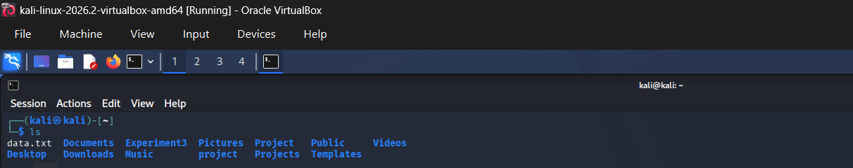
Explanation: The ls command is used to list the files and directories present in the current directory.
2. cat Command
Command:
cat data.txt
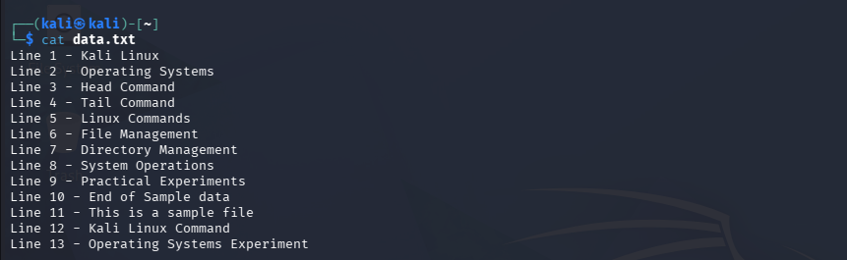

Explanation: The cat command is used to display the contents of a text file. Here, cat data.txt displays all the contents stored in the data.txt file.
3. mkdir Command
Command:
mkdir Experiment4
Explanation: The mkdir command is used to create a new directory. Here, it creates a directory named Experiment4.
To verify that the directory was created, execute:
ls
The Experiment4 directory should now appear in the output.

Result: Thus, the ls, cat, and mkdir commands were successfully executed in Kali Linux, and their outputs were displayed and verified.

